Lab Experiment: 7

Title: Sending Temperature Data from NodeMCU ESP8266 to ThingSpeak Cloud
Course title: IOT Laboratory

Course code: CSE-460
4th Year 1st Semester Examination 2025

Date of Submission: 12/04/2026

Submitted to-

Dr. Md. Ezharul Islam, B.SC.(JU), M.ENGG.(JAPAN), PHD(JAPAN)
Professor
Department of Computer Science and Engineering
Jahangirnagar University

&

Samsun Nahar Khandakar
Assistant Professor
Department of Computer Science and Engineering
Jahangirnagar University
Savar, Dhaka-1342

Class Roll | Exam Roll | Name
383 | 210903 | Abdullah Nazmus-Sakib
379 | 210899 | Shah Sultan
391 | 210911 | Md Khaled Mahmud

📘 1. Title
Sending Temperature Data from NodeMCU ESP8266 to ThingSpeak Cloud

🎯 2. Objective
- To interface LM35 temperature sensor with NodeMCU
- To connect NodeMCU to the internet via WiFi
- To send real-time temperature data to ThingSpeak cloud platform
- To visualize sensor data using an online dashboard

🧰 3. Components Required

Component | Quantity
NodeMCU ESP8266 | 1
LM35 Temperature Sensor | 1
Micro USB Cable | 1
Laptop with Arduino IDE | 1
Internet Connection | 1
ThingSpeak Account | 1

🔌 4. Circuit Connection

🔹 LM35 Sensor → NodeMCU
- Pin 1 → 3.3V
- Pin 2 → A0 (Analog Pin)
- Pin 3 → GND
📌 As described in your lab sheet (page 1), LM35 is connected directly to A0 for analog reading

💻 5. Program (Arduino Code)

#include <ESP8266WiFi.h>
#include <WiFiClient.h>
#include <ThingSpeak.h>

const char* ssid = "YOUR_WIFI";
const char* password = "YOUR_PASSWORD";

int val;
int pin = A0;

WiFiClient client;

unsigned long myChannelNumber = YOUR_CHANNEL_ID;
const char * myWriteAPIKey = "YOUR_API_KEY";

void setup() {
Serial.begin(9600);
delay(10);

WiFi.begin(ssid, password);
ThingSpeak.begin(client);
}

void loop() {
val = analogRead(pin) * 0.322265;

Serial.print("Temperature: ");
Serial.print(val);
Serial.println("*C");

ThingSpeak.writeField(myChannelNumber, 1, val, myWriteAPIKey);

delay(15000); // Required delay for ThingSpeak
}

⚙️ 6. Working Principle
- LM35 sensor outputs analog voltage proportional to temperature
- NodeMCU reads this analog value via A0 pin
- Value is converted into temperature (°C)
- NodeMCU connects to WiFi network
- Data is sent to ThingSpeak server using API key
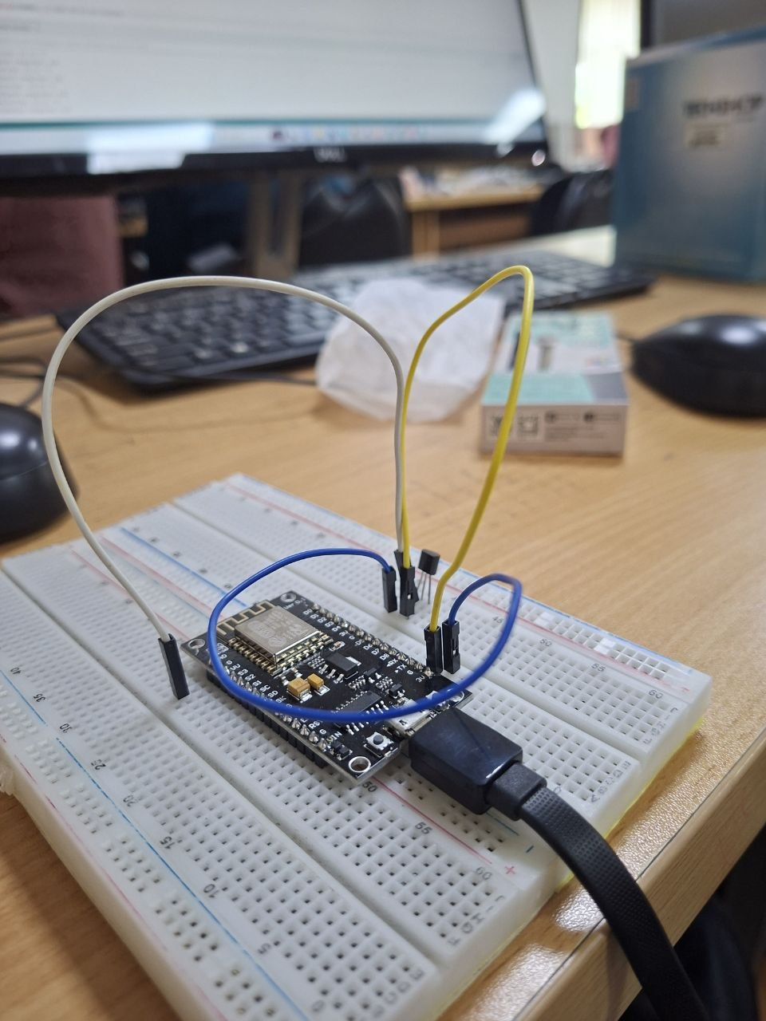
- ThingSpeak stores and displays data as a graph

▶️ 7. Procedure
- Collect all components
- Connect NodeMCU to laptop via USB
- Install ESP8266 board package in Arduino IDE
- Select NodeMCU 1.0 (ESP-12E Module)
- Connect LM35 sensor properly
- Create ThingSpeak account and channel
- Get Channel ID and Write API Key
- Install ThingSpeak library
- Write and upload the program
- Open Serial Monitor to check readings
- Open ThingSpeak dashboard to view graph

📊 8. Observation
- Serial Monitor displayed temperature values
- Data was successfully uploaded to ThingSpeak
- Graph updated automatically in real-time
- Temperature values changed according to environment

📈 9. Result
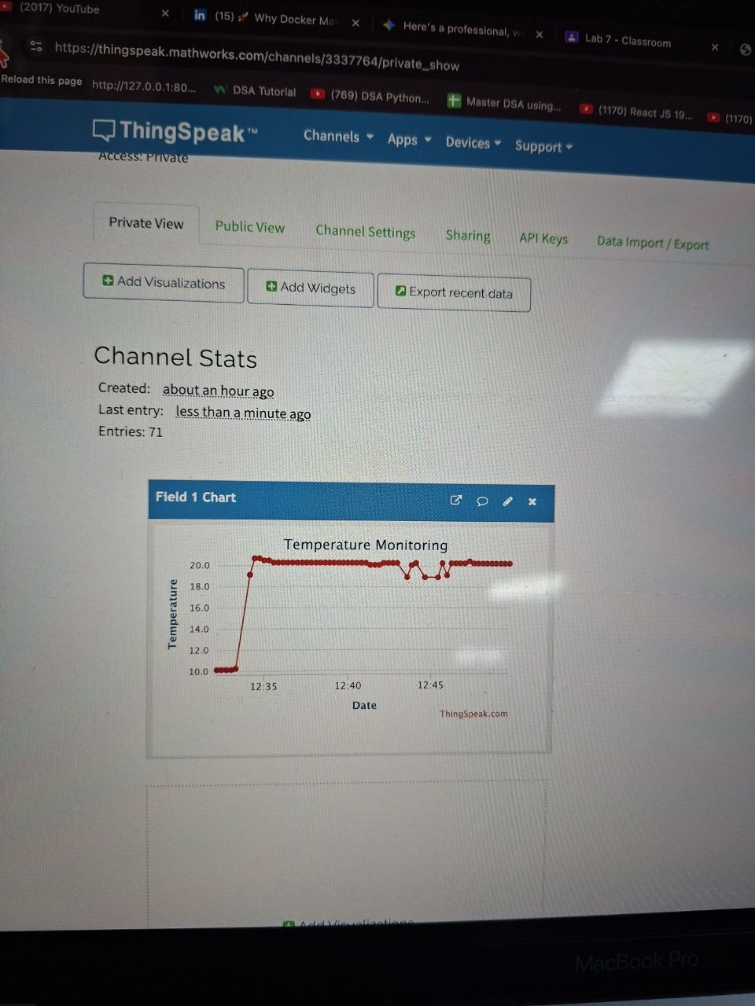

The temperature data from LM35 sensor was successfully transmitted to the ThingSpeak cloud platform using NodeMCU ESP8266 and displayed in graphical form in real-time.

🧠 10. Applications
- Smart weather monitoring systems
- Remote temperature monitoring
- Industrial IoT systems
- Smart agriculture
- Home automation

⚠️ 11. Precautions
- Ensure correct WiFi credentials
- Use correct API key and Channel ID
- Maintain stable internet connection
- Add proper delay (≥15 seconds)
- Check wiring carefully

🏁 12. Conclusion
This experiment demonstrated the integration of sensors, microcontrollers, and cloud platforms in IoT systems. It provided practical knowledge of real-time data acquisition, wireless communication, and cloud-based monitoring, which are essential for modern IoT applications.

